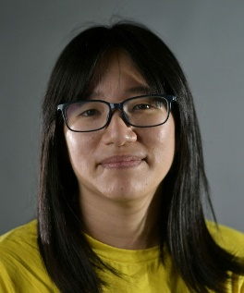 CHOW HANG-TUNG - HONG KONG
Secretary for Justice Department for Justice G/F c/o: Hong Kong Embassy 3503 International Place, NW Washington DC 20008
BEGIN COPYING HERE:
Dear Secretary,
Chow Hang-tung is serving 22 months in jail for peacefully remembering the victims of the Tiananmen Square crackdown in 1989 and is also facing further wrongful imprisonment for allegedly endangering national security through her entirely peaceful actions. I respectfully ask you to immediately and unconditionally release human rights lawyer Chow and drop all charges against her, as she has been charged solely for peacefully exercising her rights to freedom of expression and peaceful assembly. Thank you.
Sincerely,

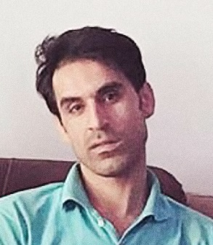 VAHID AFKARI - IRAN
Head of Iran’s Judiciary Interests Section of the Islamic Republic of Iran 2209 Wisconsin Avenue, NW Washington DC 20007
BEGIN COPYING HERE:
Dear Sir,
Vahid Afkari is being held in solitary confinement in Adelabad prison in Fars province. The large body of evidence proving his innocence is being ignored by the authorities. I respectfully urge you to release Vahid Afkari immediately as he is being detained for his peaceful participation in protests. Pending his release, he must be held in conditions meeting international standards for the treatment of prisoners, with access to adequate healthcare – outside prison if necessary – and to his family. Thank you.
Sincerely,
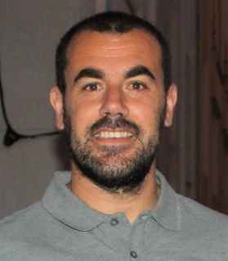 NASSER ZEFZAFI - MOROCCO

Head of Moroccan Government The Embassy of the Kingdom of Morocco 1601 21st Street, NW Washington DC 20009
BEGIN COPYING HERE:
Your Excellency:
I respectfully call on you to immediately and unconditionally release Nasser Zefzafi and quash his unfair conviction, as he is imprisoned for exercising his right to protest. The prison authorities have denied him the medical care he needs. Pending his release, please ensure that Nasser is protected from torture and other ill treatment and that he has access to adequate healthcare in prison. Thank you.
Sincerely,

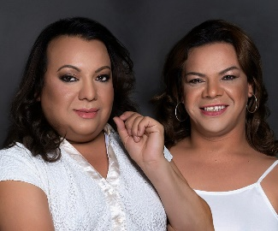 YREN ROTELA AND MARIANA SEPÚLVEDA - PARAGUAY
President of the Supreme Court of Justice of Paraguay The Embassy of Paraguay 2400 Massachusetts Avenue, NW Washington DC 20008
BEGIN COPYING HERE:
Your Excellency,
I respectfully call on you to guarantee all means to legally recognize the identities of Yren Rotela and Mariana Sepúlveda, two transgender women. Denying them the right to legally change their names and obtain identity documents matching their gender identity is discriminatory. It impacts their ability to gain equal education, employment, housing, healthcare, and further exposes them to violence, harassment and stigma. In Paraguay, trans activists are silenced and their protests are often banned or attacked. I call on you to guarantee legal frameworks to end this discriminatory practice.
Sincerely,

 ALEKSANDRA SKOCHILENKO - RUSSIA
The Prosecutor of Saint Petersburg c/o: The Embassy of the Russian Federation 2650 Wisconsin Avenue, NW Washington DC 20007
BEGIN COPYING HERE:
Dear Prosecutor,
I respectfully call on you to ensure the release of Aleksandra Skochilenko, who is being detained for criticizing Russia’s war against Ukraine. Article 19 of the Universal Declaration of Human Rights says that everyone has a right to freely express their opinions. All charges against her should be dropped and she should immediately and unconditionally be released from prison. Aleksandra must also be protected from harassment by detention center employees and her cellmates.
Sincerely,

JOANAH MAMOMBE, NETSAI MAROVA AND CECILLIA CHIMBIRI - ZIMBABWE
President Emmerson Dambudzo Mnangagwa c/o: The Embassy of the Republic of Zimbabwe 1608 New Hampshire Avenue, NW Washington DC 20009

BEGIN COPYING HERE
Your Excellency,
I respectfully call on you to immediately and unconditionally drop all charges against Joanah Mamombe, Netsai Marova and Cecillia Chimbiri, charged solely for the peaceful exercise of their rights to freedom of expression and peaceful assembly. All three were arbitrarily arrested following a protest in Harare, taken to a police station, and forcibly driven out of the city to a place where they were beaten and sexually assaulted. While still hospitalized, they were charged with offences related to the protest and later charged with faking their ordeal. Joanah, Netsai and Cecillia have suffered continuous harassment since their arrest and must be protected. Thank you.
Sincerely,
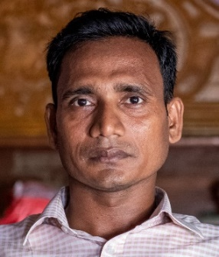 SHAHNEWAZ CHOWDHURY - BANGLADESH
Minister of Justice Law and Justice Division Ministry of Law c/o: The Embassy of the People's Republic of Bangladesh 3510 International Drive, NW Washington DC 20008
BEGIN COPYING HERE:
Honorable Minister,
I respectfully call on you to immediately and unconditionally drop all charges against Shahnewaz Chowdhury, who is charged under Bangladesh’s Digital Security Act (DSA) and if convicted faces up to a decade in prison just for expressing his views on Facebook. The DSA is being weaponized by the government and powerful non-state actors to stifle dissent. I call on you to repeal or amend the DSA and other domestic laws in line with international human rights standards on the right to freedom of expression. Thank you.
Sincerely,
 DORGELESSE NGUESSAN - CAMEROON
President of The Republic of Cameroon c/o: The Embassy of the Republic of Cameroon 3400 International Drive, NW Washington DC 20008
BEGIN COPYING HERE:
Your Excellency,
I am writing to respectfully demand the immediate and unconditional release of Dorgelesse Nguessan, who is detained solely for the peaceful exercise of her rights to freedom of expression and peaceful assembly. Dorgelesse was arrested in Douala, while attending her first ever protest. She had never been politically active, but her concerns about the state of Cameroon’s economy led her to join the demonstrations. Dorgelesse was found guilty of “insurrection, assembly, meetings and public demonstrations” and after an unfair trial by a military court she was sentenced to five years in prison. She must be freed and returned to her family, who rely on her as the main wage-earner. Thank you.
Sincerely,
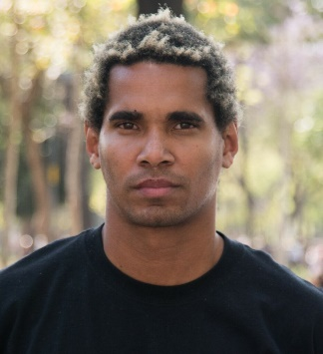 LUIS MANUEL OTERO ALCÁNTARA - CUBA
President of Cuba C/O The Embassy of Cuba 2630 16th Street, NW Washington DC 20009
BEGIN COPYING HERE:
Dear President,
I respectfully call on you to immediately and unconditionally release prisoner of conscience Luis Manuel Otero Alcántara. He has been detained solely for peacefully exercising his rights to freedom of expression and peaceful assembly. Hia trial was unfair and took place behind closed doors without access for independent human rights monitors or journalists. While in prison Luis Manuel’s health has reportedly deteriorated. Thank you.
Sincerely,

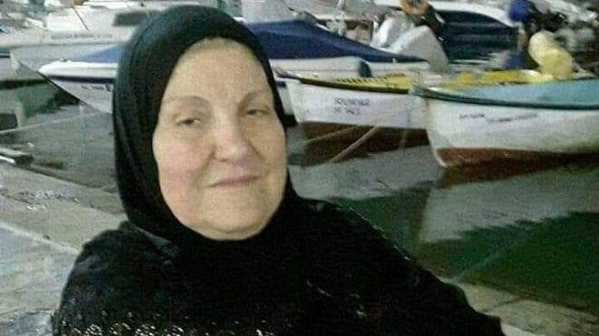 ZINEB REDOUANE - FRANCE
Juges d’instruction Tribunal c/o: The Embassy of France 4101 Reservoir Road, NW Washington DC 20007
BEGIN COPYING HERE:
Dear Investigating Judges,
I am writing to respectfully demand full accountability for the killing of Zineb Redouane, who died due to an alleged unlawful use of tear gas grenades during a protest. The responsibility of the officer who fired the grenade and his chain of command should be fully ascertained. Please duly consider all the existing evidence and, if the evidence warrants it, ensure that all suspects are tried in proceedings that respect their right to a fair trial. Thank you.
Sincerely,

WNBA STAR AND OLYMPIC ATHLETE SENTENCED TO 9 YEARS IN RUSSIAN PENAL COLONY FOR VAPE CARTRIDGE HELP BRING BRITTNEY GRINER HOME!
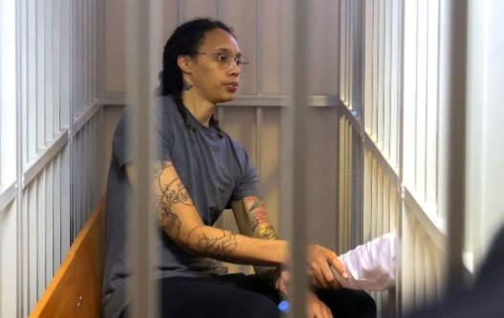
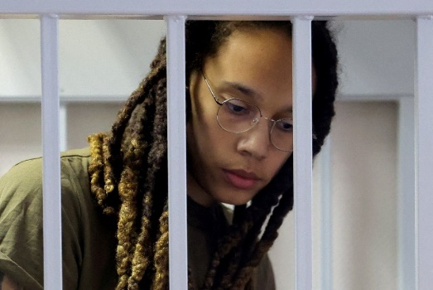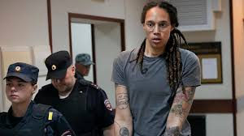
Sign the petition for Brittney Griner’s release: Go to: https://chng.it/JM2jgyZc9w And see other paper to send her a message through her family. For more go to wearebg.org

1. WRITE TO BG
LET BRITTNEY KNOW YOU ARE THINKING ABOUT HER. YOU CAN SEND HER AN EMAIL (WEAREBG@TEAMWASS.COM) OR SEND A HANDWRITTEN NOTE which will be sent TO:
WE ARE BG C/O
WASSERMAN
PO BOX 251949
LOS ANGELES, CA 90025

2. FOLLOW
FOLLOW WEAREBG, WNBPA AND ATHLETES FOR IMPACT ON SOCIAL MEDIA FOR THE LATEST CONTENT, UPDATE, AND INFO: @TheWNBPA or @Athletes4Impact

3. SHARE WITH YOUR COMMUNITY
WHETHER YOU HAVE 1 FOLLOWER OR 10 MILLION, WE WANT YOU TO SHARE YOUR WORDS OF ENCOURAGEMENT IN SUPPORT OF BRITTNEY USING THE HASHTAGS #WEAREBG AND #BRINGTHEMHOME.
- SELF RECORD A VIDEO SHARING WORDS OF SUPPORT
- POST YOUR NOTE OR A PHOTO OF YOUR HANDWRITTEN NOTE AND SHARE ON SOCIAL MEDIA
- HAVE A MEDIA PLATFORM? READ YOUR LETTER TO YOUR AUDIENCE 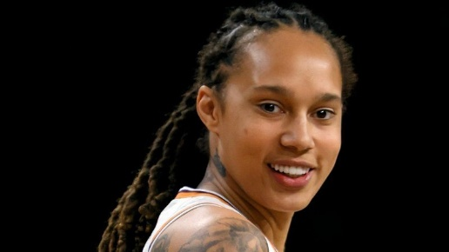 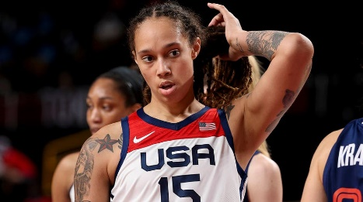 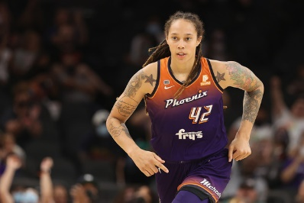 HELP BRING BRITTNEY GRINER HOME!

