  Mission Statement
  The Academic Support Center’s mission is to encourage and empower students of all abilities and backgrounds to reach their fullest learning potential, while striving to meet their academic goals, degree requirements and career aspirations.
  Personalized Approach to Success
  Our Academic Coaches utilize Starfish, an early alert system, which fosters communication between a student and their success network. The use of Starfish helps coaches work collaboratively with students to achieve academic and social integration into the Herkimer College community.
  Interested in academic coaching?
  If you are interested in working with an Academic Coach—please reach out! Stop by the Academic Support Center or give us a call to schedule an appointment! Coaches can be met through face-to-face or online appointments. For more information, technical support, or to make an appointment, please call the phone number listed below.
  Herkimer County Community College
  100 Reservoir Road, Herkimer, NY 13350
  Herkimer, NY 13350
  Phone: 315-866-0300 x8275
  Web: https://www.herkimer.edu/learn/academic-support-center/
  1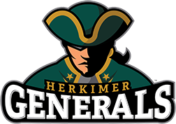 | ACADEMIC SUPPORT CENTER  Herkimer County Community College  100 Reservoir Road, Herkimer, NY 13350  Herkimer, NY 13350
  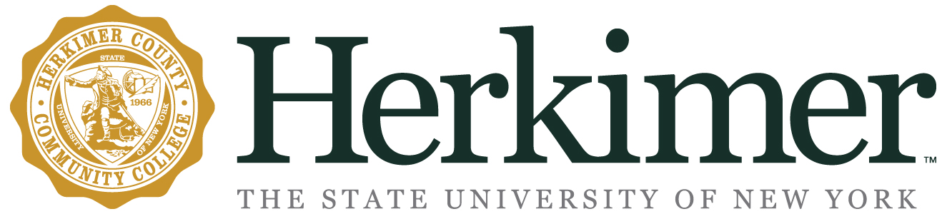
  Academic Coaching
  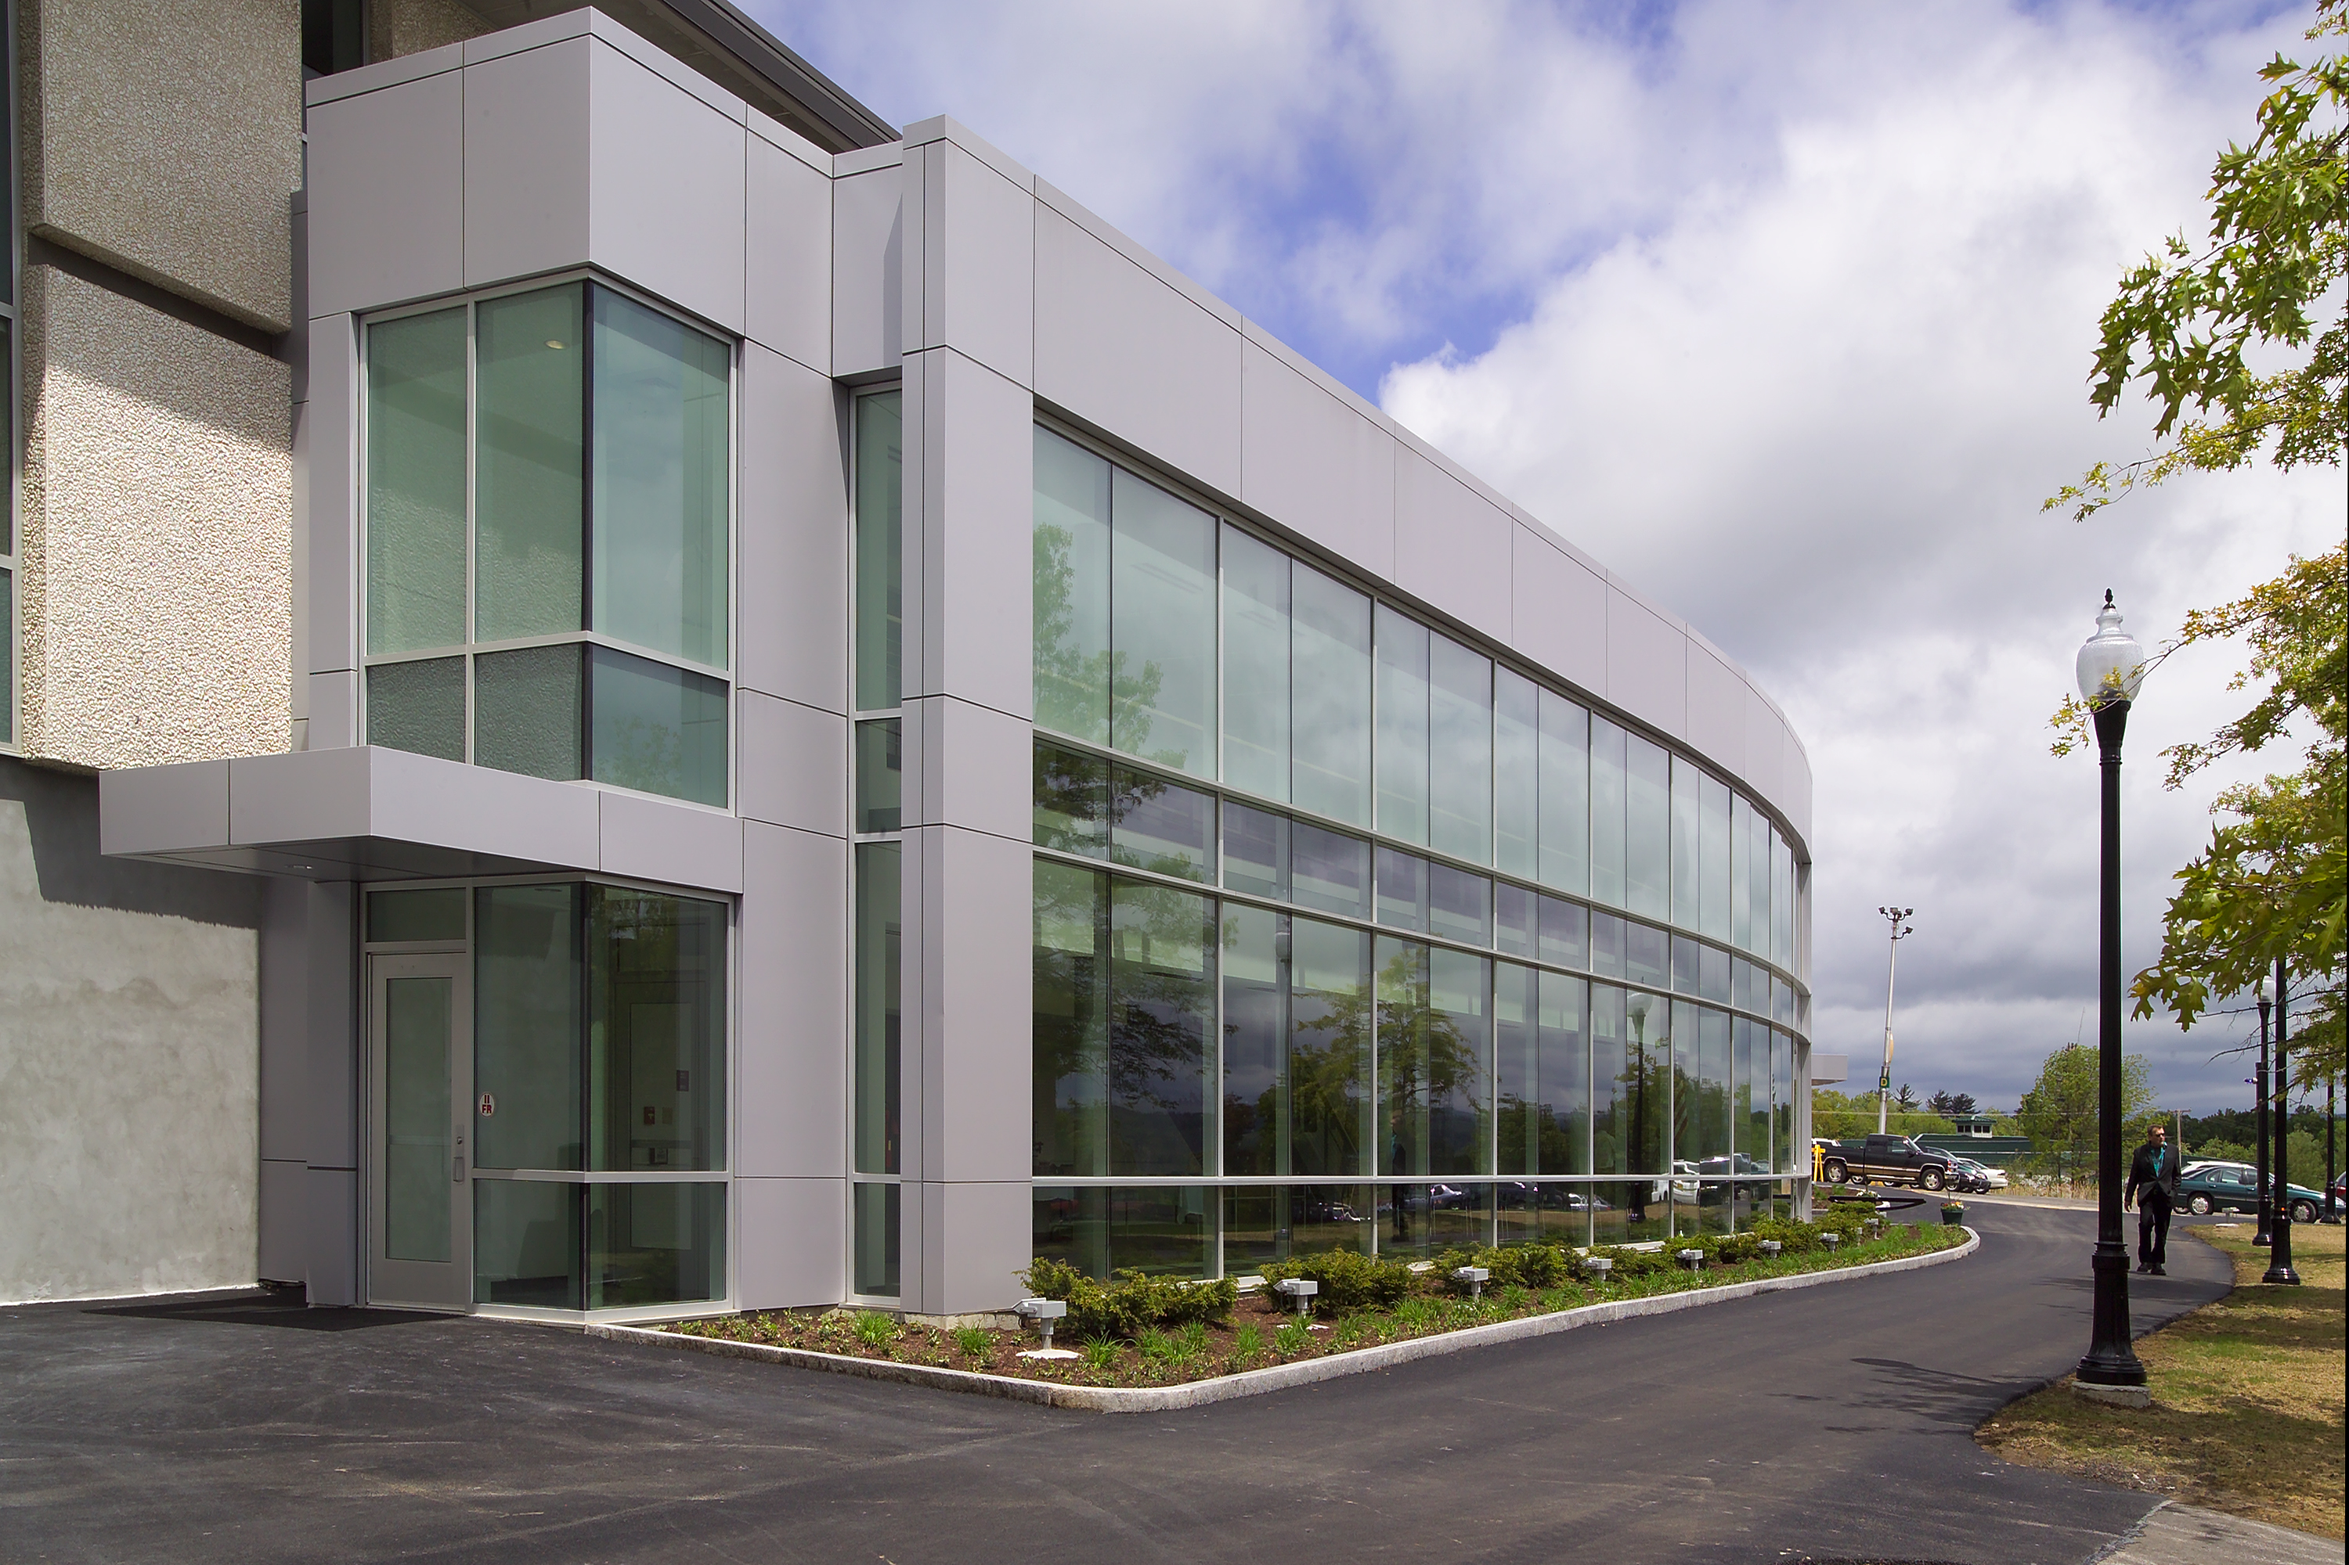
  ACADEMIC SUPPORT CENTER
    - Library 104

What is academic coaching?  The National Academic Advising Association (NACADA) defines Academic Coaching as: “…an interactive process that focuses on the personal relationship created between the student and the coach. The coach challenges the student to think about their personal and professional goals in order to relate them to their academic/educational goals. In this learning process, it is important for the coach to encourage the student to become more self-aware by understanding their strengths, values, interests, purpose, and passion.”  “Personal connections are often the central mechanisms and daily motivator of the student experience.” –Daniel Chambliss, How College Works  Academic Coaches can assist with:  - Time Management  - Goal Setting  - Study Skills  - Interpersonal Communication Skills  - Stress Management  - Organization | “ |  | Meet Our Coaches!  Jody Edick  Keith Heinrich  Justin Thompson  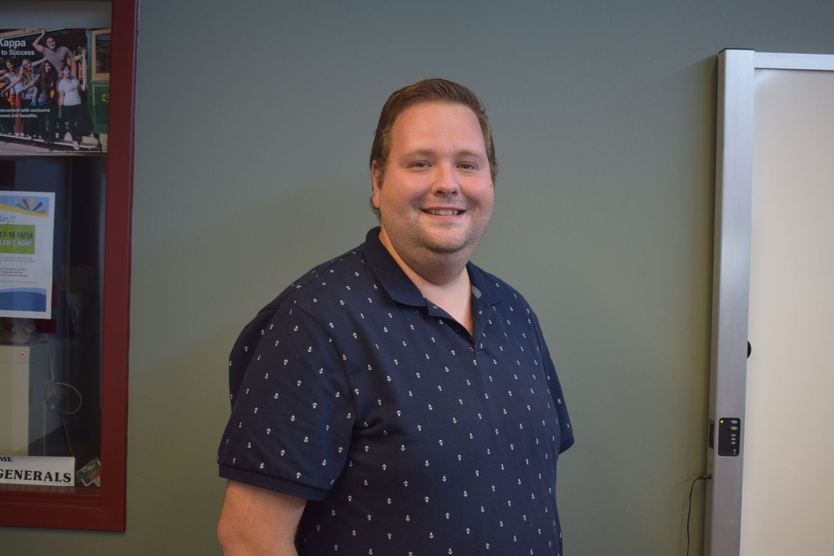  Justin coaches students in the Criminal Justice major. He has worked for several years as a professional CJ tutor having earned a degree in the major at Herkimer himself. He also has a Bachelor’s in CJ and Sociology from SUNY Poly and a Master’s in CJ from Grand Canyon University. Justin also acts as an embedded tutor in criminal law classrooms studying the material alongside students in order to more holistically assist the students in all their needs.
   | Jody assists students who major in Business, Education, and General Studies. Areas of research interest include: frameworks for understanding teaching and learning, improving college retention and graduation rates, First- Generation Student success in higher education, and supporting students who are in recovery in higher education. She is involved in Strong Start to Finish research at Herkimer College. She teaches classes at Herkimer College and SUNY Oneonta. She earned an A.A. from Fulton Montgomery Community College, B.S. from SUNY Plattsburgh, and a M.Ed. from the University of Vermont. She enjoys her role as the Generals F1rst and Chess Club advisor.
  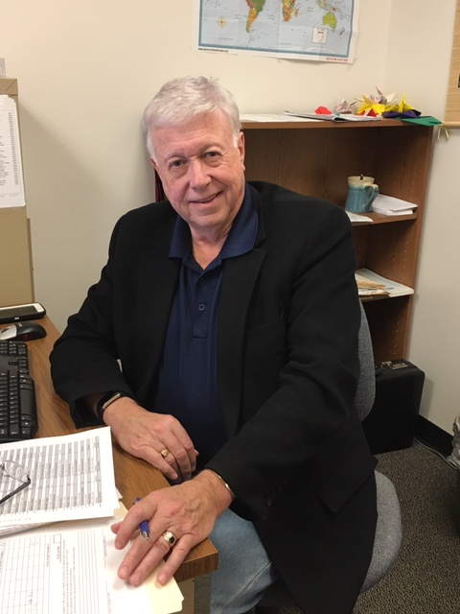 | Keith collaboratively works alongside our Services for Students with Disabilities office to provide individualized coaching for our Career and Technical Education (CTE) students with disabilities. In addition to teaching two courses in the field of health for Herkimer’s Internet Academy, Keith is a proud board member of the Masonic Care Community in Utica.
  Denise Cavanaugh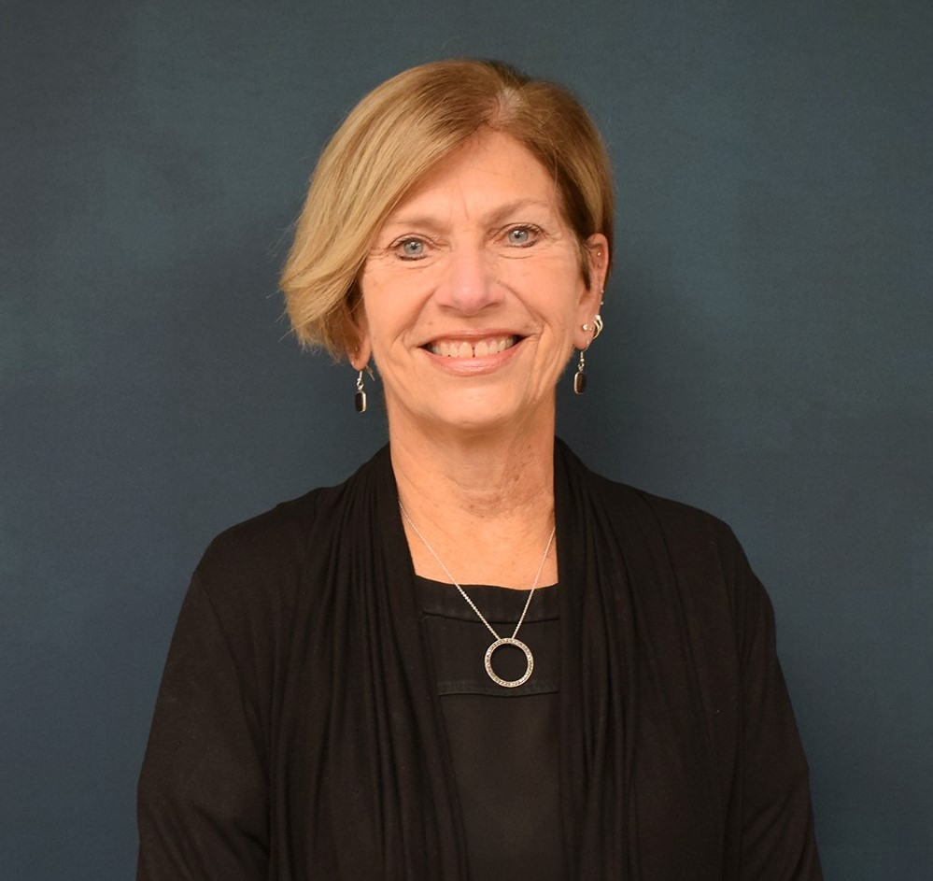 | Denise coaches students in the Health Professions and Humanities majors. She held several leadership positions in the community. She holds a bachelor’s degree from Russell Sage College and a master’s degree in counselor education from SUNY Oneonta. She is currently pursuing an Ed.D. in Executive Leadership from St. John Fisher College.

